**Supplement A. Similarity of replicate samples from within a hole.**

Up to three samples were preserved from each sample, but all three were not available for all samples. We extracted and sequenced the DNA from 0.4 g of each technical replicate separately. Visual inspection of PCoA biplots suggested technical replicates were similar to one another relative to the entire data set (Figure A.1), particularly for bacteria (Figure A.1a). In order to ask whether the difference between technical replicates was sufficiently small that we would expect to obtain the same result no matter which one was chosen per sample, we jackknifed the data set to select different random samples of one technical replicate per hole, calculated UniFrac (Lozoupone & Knight, 2007), and reran the regressions for key analyses, such as the relationship between beta diversity in bacteria and eukaryotes. After 1000 replicates, we report the distributions for resulting *r* and *P* values in Table A.1.

**Table A.1.** Mean, variance, minimum, and maximum values for *r* and *P* values for the Model II regression between bacterial and eukaryotic beta diversity (UniFrac) presented in the main text, using 1000 iterations of random selection of a single technical replicate per sample.

|  |  |  |  |  |
| --- | --- | --- | --- | --- |
| Parameter | Mean | Variance | Min | Max |
| r | 0.93 | 0 | 0.91 | 0.96 |
| p-value | 0.00 | 0 | 0.00 | 0.00 |

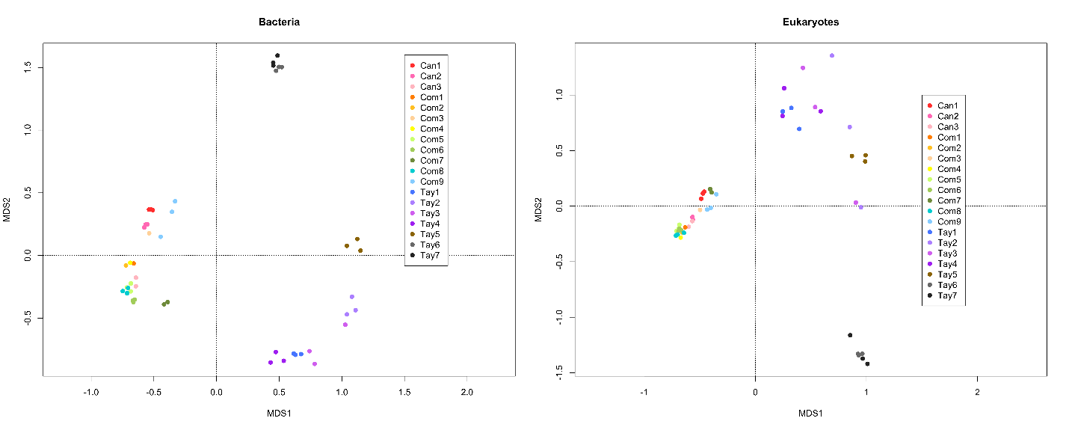

**Figure A.1** Multidimensional scaling ordination of bacterial and eukaryotic beta diversity (UniFrac) by sample using R (R Core Team 2016) package vegan (Oksanen et al. 2013), including all technical replicates. Color indicates sample, with up to three technical replicates sequenced per sample.

**Supplement B: Multicollinearity of physicochemical factors and variable selection**

To explore the effect of physicochemical factors on alpha diversity through multiple regression, we needed to reduce collinearity. The total set of measured characteristics exhibited strong multicollinearity after centering and standardizing them (Figure B.1). We therefore used a collinearity threshold of |r| < 0.7 as recommended by the simulations of Dormann *et al.* (2013) to remove depth, which negatively correlated with longitude (*r* = -0.90) and both major cations and anions, both of which correlated strongly with EC (cations: *r* = 0.97, anions: *r* = 0.89). We chose depth to eliminate instead of longitude because we had a clear hypothesis about how location may influence community diversity, and no clear biologically mechanistic hypothesis about how depth would affect diversity. We chose EC rather than either of the major groups of ions as an integrative measure of ionic concentration.

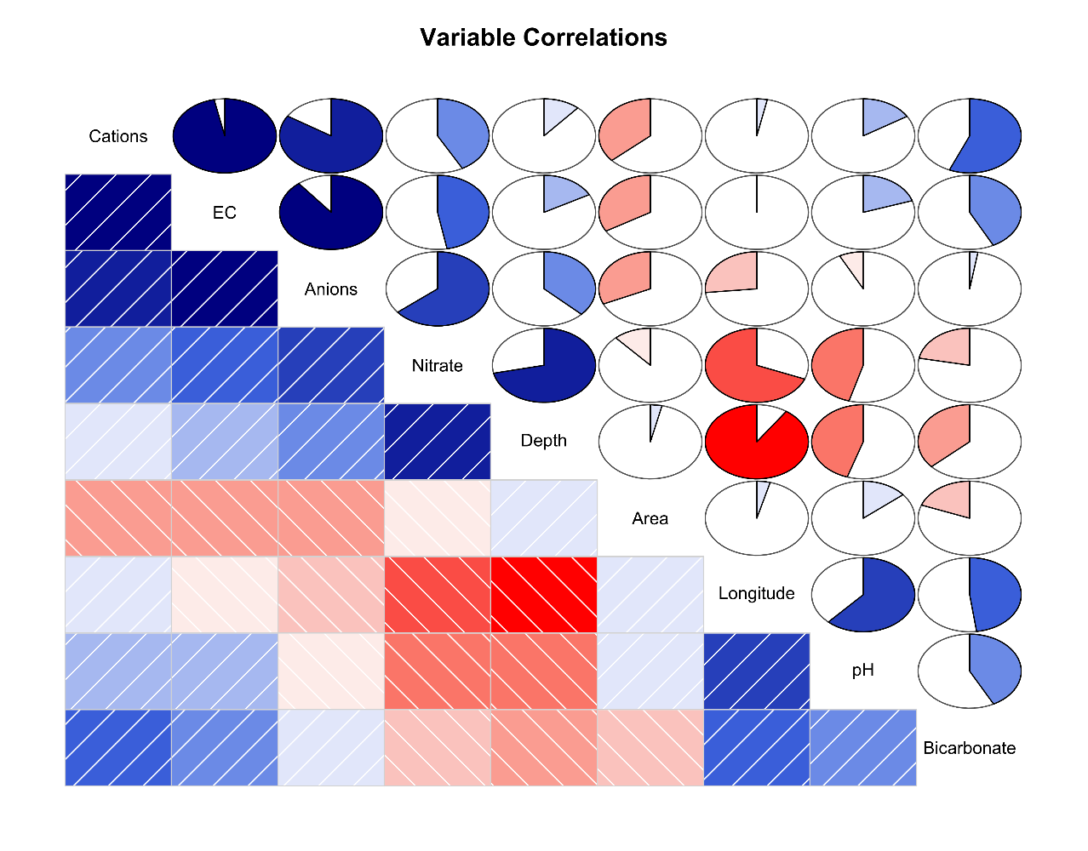

**Figure B.1.** Visualization of how measured physical and chemical factors varied together along the Taylor Valley using package corrgram v 1.11 (Wright, 2012) in R (R Core Team 2016). The lower triangle shows each pairwise correlation. The upper triangle uses pie charts to visualize Pearson’s *r* value for each correlation.

**Table B.1.** Physicochemical characteristics of each sample. Abbreviations and units as follows: Lat = latitude in degrees, Long = longitude in degrees, Area = surface area of hole in cm2, Depth = depth to bottom of sediment in cm, EC = electrical conductivity in µS/cm, NO3- = nitrate ions in ueq/l, HCO3- = bicarbonate ions in ueq/l, DOC = dissolved organic carbon in ppm, “-” = summed cations, including Na+, K+, Mg2+, and Ca2+ in ueq/l, and “+” = summed anions, including F-, Cl-, and SO42-, in ueq/l.

|  |  |  |  |  |  |  |  |  |  |  |  |  |  |  |  |  |  |  |  |
| --- | --- | --- | --- | --- | --- | --- | --- | --- | --- | --- | --- | --- | --- | --- | --- | --- | --- | --- | --- |
| **+** | 119.6 | 509 | 78.79 | 493.7 | 589.2 | 413 | 271.2 | 237.7 | 169.8 | 157.3 | 595.9 | 749.8 | 43.4 | 765.7 | 187.3 | 124.9 | 163 | 522.6 | 681.2 |
| **-** | 65.24 | 308.2 | 37.21 | 392.8 | 353.2 | 59.51 | 198.9 | 128.5 | 108.7 | 114.1 | 476 | 221.6 | 28.28 | 719.9 | 173 | 113.1 | 136.5 | 433.8 | 569.8 |
| **DOC** | NA | 1.8 | NA | 2.2 | 1.3 | NA | 0.8 | 0.2 | 0.3 | 0.4 | 1.1 | 2.3 | NA | 0.4 | 0.2 | NA | 0.2 | 0.3 | 0.4 |
| **HCO3-** | 53.4 | 200.6 | 40.93 | 100.6 | 235.9 | 353.5 | 72.25 | 109 | 60.88 | 43.22 | 119.5 | 528 | 13.91 | 36.63 | 12.85 | 9.75 | 21.84 | 79.41 | 94.6 |
| **NO3-** | 1 | 0.26 | 0.66 | 0.22 | 0.07 | 0.08 | 0.06 | 0.17 | 0.21 | 0.07 | 0.42 | 0.12 | 1.21 | 9.18 | 1.48 | 2.05 | 4.67 | 9.38 | 16.8 |
| **EC** | 15 | 61 | 12 | 47 | 50 | 36 | 25 | 21 | 15 | 21 | 54 | 52 | 5.3 | 73 | 19 | 14 | 18 | 49 | 64 |
| **pH** | 7 | 10 | 7 | 7 | 10 | 7 | 8 | 7 | 7 | 7 | 7 | 7 | 6 | 6 | 6 | 6 | 6 | 6 | 6 |
| **Depth** | 29 | 40.5 | 37.5 | 25.5 | 35 | 19 | 22.5 | 38 | 29 | 30 | 26 | 33 | 34.5 | 57 | 55 | 56 | 60 | 61 | 59 |
| **Area** | 779.29 | 730.6 | 4185.3 | 424.54 | 804.22 | 471.42 | 388.81 | 881.39 | 948.39 | 153.93 | 330.05 | 314.15 | 572.54 | 433.72 | 510.69 | 1149.1 | 541.17 | 660.5 | 490.86 |
| **Long** | 163 | 163 | 163 | 163.3 | 163.3 | 163.3 | 163.3 | 163.3 | 163.3 | 163.3 | 163.3 | 163.3 | 162.2 | 161.8 | 161.8 | 161.8 | 161.8 | 161.8 | 161.8 |
| **Lat** | 77.6 | 77.6 | 77.6 | 77.6 | 77.6 | 77.6 | 77.6 | 77.6 | 77.6 | 77.6 | 77.6 | 77.6 | 77.7 | 77.8 | 77.8 | 77.8 | 77.8 | 77.8 | 77.8 |
| **Status** | Wet | Wet | Wet | Wet | Wet | Wet | Wet | Wet | Wet | Wet | Wet | Frozen | Wet | Wet | Wet | Wet | Wet | Wet | Wet |
| **Lid** | closed | closed | closed | closed | closed | open | closed | closed | closed | closed | closed | closed | closed | closed | closed | closed | closed | closed | closed |
| **Glacier** | Canada | Canada | Canada | Common | Common | Common | Common | Common | Common | Common | Common | Common | Taylor | Taylor | Taylor | Taylor | Taylor | Taylor | Taylor |
| **Sample** | Can156 | Can157 | Can160 | Como57 | Como58 | Como59 | Como61 | Como63 | Como64 | Como65 | Como70 | Como80 | Tay34 | Tay35 | Tay36 | Tay37 | Tay43 | Tay44 | Tay45 |

**References for Supplement**

Dormann, C.F., Elith, J., Bacher, S., *et al*.. Collinearity: a review of methods to deal with it and a

simulation study evaluating their performance. *Ecography* 2013; **36**: 27-46.

Lozupone C & Knight R. UniFrac: a new phylogenetic method for comparing microbial

communities. *Applied and Environmental Microbiology* 2005; **71**: 8228-8235.

Oksanen, J., F. G. Blanchet, R. Kindt, P. Legendre, P. R. Minchin, R. O’hara, G. L. Simpson, P. Solymos, M. H. H. Stevens, and H. Wagner. 2013. Package ‘vegan’. Community ecology package, version **2**.

R Core Team. 2016. R: A language and environment for statistical computing. Vienna, Austria. R Foundation for Statistical Computing, Vienna, Austria.

Wright K (2012) corrgram: Plot a Correlogram. *R package version* **1**.